Alan Yu

Organic Lab 309:03

Santanu Malakar

Experiment 47: Synthesis of Dimedone and Measurement of Its Tautomeric Equilibrium Constant

April 1, 2019

**Purpose:**

The purpose of this experiment is to synthesize dimedone from 4-methyl-3-penten-2-one.

**Equations:**

**Mechanisms:** (From Lecture Notes)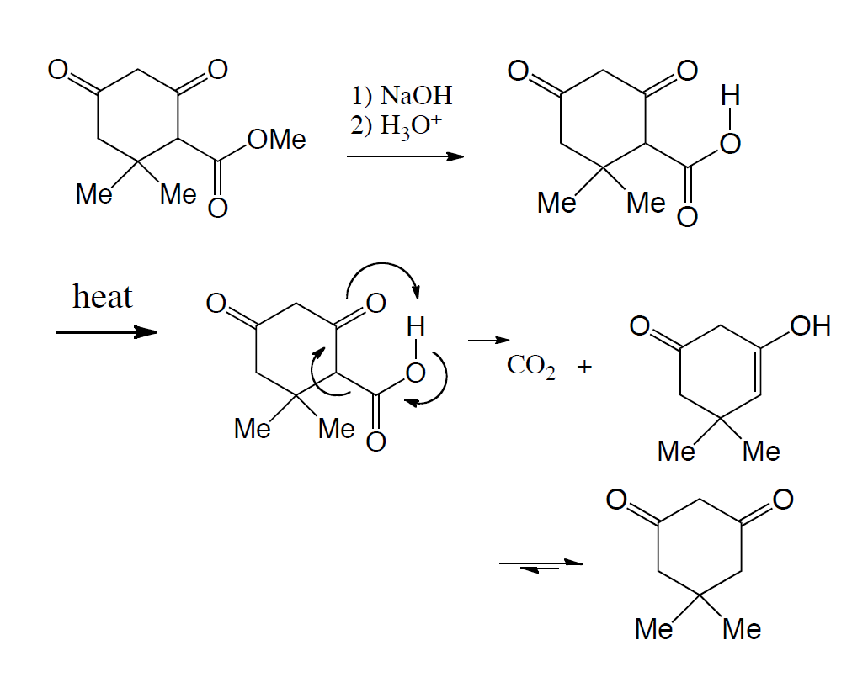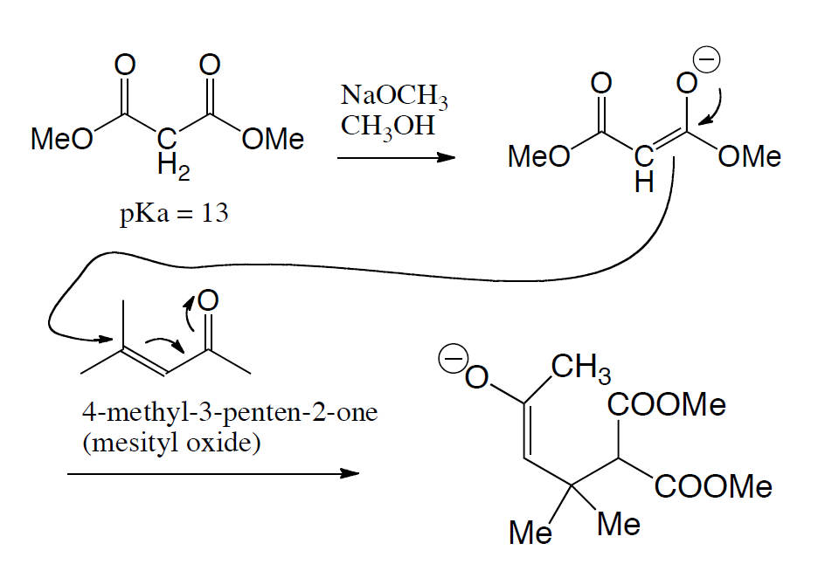

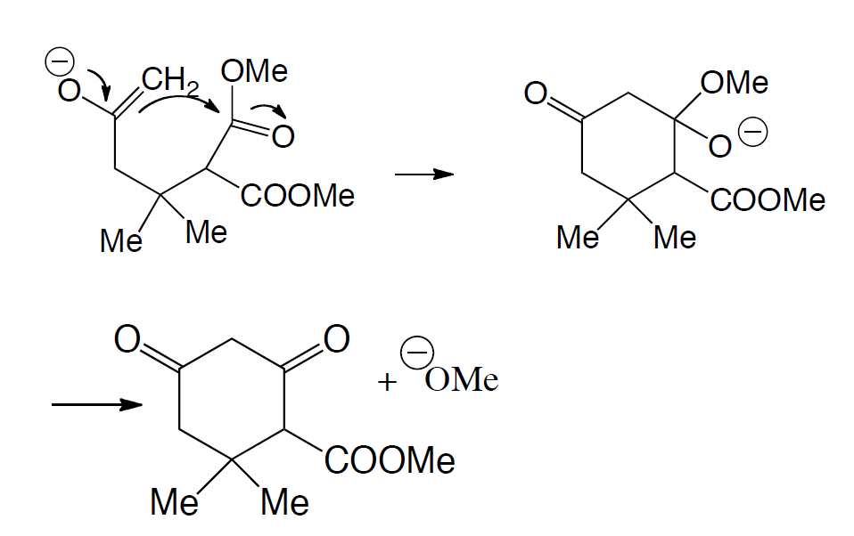

**Amounts and Properties:**

Table 1: Important properties and amounts for experiment

| **Chemicals** | **Mol Wt** | **MP** | **BP** | **d** | **Amount** |
| --- | --- | --- | --- | --- | --- |
| Mesityl Oxide | 98.2 | -52 | 129 | .858 | 3 mL |
| Dimethyl Malonate | 132.1 | -62 | 181 | 1.154 | 25 mmol |
| Sodium Methoxide | 54 |  |  |  | 6 mL |
| Methanol | 32 | -94 | 65 | .791 |  |
| Dimedone | 140.2 | 151 |  |  |  |
| NaOH, 3M |  |  |  |  | 20 mL |
| HCl, 6M |  |  |  |  | 15 mL |

**Hazards and Safety:**

Sodium Methoxide/methanol is corrosive, toxic and flammable. Contact or inhalation can cause severe damage to skin, eyes, and respiratory tract. Wear gloves, avoid contact and don’t inhale vapors and keep away from flames. Mesityl oxide is a lachrymator and strong irritant, don't’ inhale or touch. Don’t let it distill to dryness since it forms explosive peroxides. DCF is harmful if inhaled or absorbed through skin and is a carcinogen. Avoid contact and inhalation. Dispose all chemicals within marked containers under the hood.

**Procedure:**

**Reaction**:

The reaction apparatus needs to be dry because the first step creates an enolate which can reaction with water, destroying the whole experiment. Adding the sodium methoxide with the dimethyl malonate is to induce a Michael addition between the mesityl oxide and the malonate at the later step. After the Michael addition, there is a Claisen Condensation that is created during the reflux for the first hour. The methoxide has to evaporate before the Sodium Hydroxide is added or else the methoxide will react with the sodium hydroxide. The Sodium hydroxide is added after the Claisen condensation is about done to induce saponification, HCl is added to induce acidification, and the heat is added to induce the decarboxylation process.

**Separation and Purification / Analysis:**

Letting the product recrystallize, the recrystallization part can be done again to remove impurities from the sample.

**Observations:**

When the malonate and the sodium methoxide was added, the mixture became a yellowish color which looked like the mixing of egg whites and the yolk. When the solid began to dissolve, the solution became a clear yellow solution. After adding the mesityl oxide, the solution became a brownish yellow which resembles vanilla extract but lighter. As the solution was being evaporated slowly, the solution began to look like that of a sponge cake that was orangish yellow. Adding the NaOH after creating that goo like solid solution, the solution became a clear orange yellow solution. The solid that was collected from vacuum filtration had a mixture of both white and yellowish, which showed impurities. Recrystallizing with the acetone produced a solution that had a clear and light yellow tint to it. This was later filtered again and dried that created a light orange solid that was the prospected item.

**Measurements:**

Table 2: Data Collected from Lab

| Malonate Used: | 3.284g |
| --- | --- |
| MP Plateau: | 126 - 130 degrees C |
| Mass final: | 1.577g yielded |

**Data and Calculations:**

3.284g $\frac{140.2g}{132.1g} = 3.485g Dimedone theoretically$

$\frac{1.577g}{3.485g} * 100 = 45.25\% yielded$

*

**Discussions:**

For Dimedone, the documented melting point is 151 degrees C. The plateau that was observed was from 126 to 130 degrees C. This could have been an error with the thermometer not being calibrated properly or the sample still being wet when put inside the melting point machine. Since the percent yield was under 50%, a possible error could have been adding the sodium hydroxide before all of the methanol has been evaporated. This allows the methanol to react with the hydroxide to create methoxide with can react with the product that is sought after. From the H-NMR since the Keto peak of H is around 3-4 ppm, and the enol peak is around 5-6 ppm, the difference in area can be seen and the prediction that could be made is that the keto product was preferred over the enol product.

**Conclusions:**

Since the peak for the keto H is around 3 - 4 and for the enol H is around 5 - 6, a K constant for keto-enol tautomerization can be calculated.

$K = \frac{2 * .15}{1}=.3$

This value is .3 which suggests that there is more keto than enol that is preferred as the product of the reaction.

**Exercises:**

1. A. From the mesityl oxide H-NMR, there are four peaks that are shown. There are two peaks that are relatively close to each other around the 2 range, which could relate to the one of the branched methyl groups on the opposite side of the ketone group and the methyl group on the side of the ketone. The one with the higher ppm is the one closer to the ketone group. The one at the 6 range is the one Hydrogen that is right next to the ketone group and the one that is around the range of 1.9 can be the other methyl group that is on the opposite side of the ketone. For the NMR gathered in the lab, the H-NMR has a bigger peak around the 3-4 range compared to that of the 5-6 range. Since the keto Hydrogen is in the 3-4 range, that means that the reaction favors more keto product than that of the enol product. B. For mesityl oxide’s IR, the 2900 to 3000 range can be the C-H stretches that are within the compound. For the 1689.7 band, this band would be the stretch of the unsaturated ketone in this compound. Near the 1620.3 band would be the C=C stretch. The rest could be the other C-H bonds of the structure.
2. Same as the Mechanisms Section:

Transition State for Decarboxylation:

6. Acetone. Acetone can undergo an aldol condensation which leads to dehydration and finally with an acidic workup yields mesityl oxide.

10.